Procedure for Echocardiographer-Led Follow-Up Valve Clinics

Category: | Procedure
Summary: | The purpose of this document is to provide clear guidelines to all members staff providing the echocardiographer led valve clinics and assign responsibilities and accountabililty
Equality Analysis undertaken: | December 2015
Valid From: | 21st April 2021
Date of Next Review: | April 2024
Approval Date/ Via: | 13th June 2016: Imaging CSU and Governance & Clinical Standards Group
Distribution: | Cardiac Physiologists, Consultant Cardiologists, Department Manager, Matron for Cardiac Medicine
Related Documents:
Author(s): | Cassandra Hammond, Lead Echocardiographer  Dr. Jim Newton, Clinical Lead for Echocardiography  Prof. Saul Myerson, Clinical Lead for Cardiac Imaging
Further Information:
This Document replaces: | 2nd document

Lead Director: | Job Title
Issue Date: | Dd month year

Contents

 | Page
Introduction……………………………………………………………………………………… | 3
Policy Statement……………………………………………………………………………….. | 3
Scope.…………………………………………………………………………....................... | 4
Aim….……………………………………………………………………………………… | 4
Definitions……………………………………………………………………………………….. | 4
Responsibilities………………………………………………………………………………….
Chief Executive…………………………………………………………………………..
Director……………………………………………………………………………………
The Board of Directors…………..………………………………………………………
Trust Management Executive..…………………………………………………………
Individuals or groups with specialist expertise (insert their role)……………………
All Managers……………………..………………………………………………………
All Staff……………………………………………………………………………………
Content of the Policy……………………………………………………………………………
Training………………………………………………………………………………………….
Monitoring compliance…………………………………………………………………………
Review of this policy……………………………………………………………………………
References……………………………………………………………………………………...
Equality Analysis…………………………………………………………………..
Document History ………………………………………………………………………………
Appendices: ………list…………………………………………………………………………

Introduction
- Valve disease is increasingly common with an ageing population and follow-up clinics led by allied healthcare professionals is becoming widely accepted. A physiologist led approach under the supervision of a consultant cardiologist has been successfully adopted at numerous centres nationally.
- Introducing a physiologist led valve clinic will provide a dedicated service run in parallel with a consultant cardiologist clinic, reducing the burden on the cardiology clinics while retaining patient access to the clinics.
Scope
This document applies to all clinical members of staff running the clinic; cardiologists, cardiac physiologists and administrative team.
Aim
The purpose of this document is to ensure that the Physiologist Led Valve Clinic is run safely and efficiently within the code of practice of Cardic Physiologists and following trust policies and procedures.

Definitions
The terms in use in this document are defined as follows:
- AfC – Agenda for Change
- ANP – Advanced Nurse Practitioner
  - BP – Blood Pressure
  - ECG – Electrocardiograph
  - Echo – Echocardiogram
  - ETT – Exercise Tolerance Testing
  - INR – International Normalised Ratio
  - NYHA – New York Heart Association (Classification score for heart failure)
Responsibilities
The Imaging Consultants are responsible for:
- Identifying suitable patients for echocardiographer led clinics
- Overall supervision of the clinic.

The Lead Echocardiographer is responsible for:

- Supervision of the Echocardiographers in clinic and the day-to-day running
- Providing time for staff to attend relevant training
- Ensuring that this document is brought to the attention of all echocardiography and relevant cardiology staff
- Contributing to development of this protocol
- Monitoring compliance with this SOP

The Specialist Echocardiographer is responibile for:

- Assessing the patient for signs and symptoms of heart failure
- Performing an echocardiogram
- Reporting findings to the patient with a clear management plan or treatment options if relevant
- Performing other baseline investigations as necessary such as BP, ECG or ETT.
- Reporting relevant findings in a clinical context and discussing with the consultant cardiologist supervising the clinic
- Managing patient expectations

Clinic operation
- Clinics will be conducted by AfC Band 7 echocardiographers and above who hold a full BSE accreditation or equivalent.
- The physiologist led valve clinic will be run under the supervision of the nominated Consultant Cardiologist.
- Clinics will be triaged and populated by the consultant cardiologist (Referral Criteria Appendix 1)
- Referrals to physiologist led clinics can only be accepted from consultant cardiologists.
- Valve follow-up clinics will be held in an echo room with access to an echo machine, BP Sphygmanometer and ECG machine.
- Each follow-up appointment will be an hour long
- Patient Introduction
- Identify patient by confirming date of birth and first line of address as per trust protocol
- Introduce yourself with job title
- Familiarise yourself with the procedure plan
- Patient assessment
1) Assess changes in any of the following:
  - Increasing shortness of breath
  - Decreasing effort tolerance
  - Evidence of heart failure such as leg swelling
  - Palpitations
  - New AF
2) Echo +/- ECG at Echocardiographer’s discretion.
3) Discussion with consultant around patient management as apppropriate
Seek Medical / Senior cardiac physiologist advice where necessary and appropriate.
Patient Follow-up Interval should be appropriate as per guideline (Appendix 3)

Training
- Cardiac Physiologists will be specifically trained to perform a good quality echo in line with acceptable national guidelines, report changes in patient’s condition and discuss treatment options with patient including good health promotion for endocarditis prophylaxis.
- Ongoing in-house training will be supported for assessement and follow-up of valve disease, supervised by consultant cardiologists.
Monitoring Compliance
Compliance with the document will be monitored in the following ways.
Aspect of compliance or effectiveness being monitored | Monitoring method | Responsibility for monitoring (job title) | Frequency of monitoring | Group or Committee that will review the findings and monitor completion of any resulting action plan
Any errors or incidents related to the clinic may require the completion of an incident form. All issues and incidents must be discussed with either the Lead Echocardiographer or the CP Service Manager. | Audit of incidents reported via Datix  Audit of clinic outcomes | Lead Echocardiographer | At least annual/ 6 monthly | Clinical Service Unit Meetings

In addition to the monitoring arrangements described above the Trust may undertake additional monitoring of this SOP as a response to the identification of any gaps or as a result of the identification of risks arising from the SOP prompted by incident review, external reviews, or other sources of information and advice. This monitoring could include:
- Commissioned audits and reviews
- Detailed data analysis
- Other focused studies
Results of this monitoring will be reported to the nominated Committee

Review
- A review by the SOP development group will be made one year after the introduction of the SOP to the area.
- An assessment of the usefulness of the SOP to those staff who have used it will be carried out. Any improvements or changes will then be made and the SOP updated.
- The SOP will then be reviewed on a on a three-yearly basis or more frequently if circumstances dictate.

References
ESC Guidelines on the management of valvular heart disease (version 2012) http://eurheartj.oxfordjournals.org/content/ehj/33/19/2451.full.pdf.
BHV ACC/AHA New Valve Disease guidelines published http://www.bhvs.org.uk/new-accaha-valve-disease-guidelines-published
ACCF/ASE/AHA/ASNC/HFSA/HRS/SCAI/SCCM/SCCT/SCMR 2011 Appropriate Use Criteria for Echocardiography. Journal of the American Society of Echocardiography 2011; 24(3): 229-267

Equality Analysis
As part of its development, this policy and its impact on equality, diversity and human rights has been reviewed, an equality analysis undertaken (see appendix attached) and no adjustments were required
Document History
Date of revision | Version number | Reason for review or update
April 2021 | 2 | Routine review – Nicola Thornton
Appendix 1: Referral Criteria

  - All patients must have at least moderate stable native valve disease or a valve prosthesis that is deemed appropriate for medium-long term follow-up by a physiologist.

  - Some patients with mild structural valve disease (e.g. bicuspid aortic valve) may also be suitable.

  - All patients must have been fully evaluated at the Oxford University Hospitals Trust, by a cardiologist or cardiac surgeon in a clinic setting before referral to the Valve follow-up clinic.

  - All patients must be deemed suitable for surveillance only. They must be asymptomatic or minimally symptomatic (no more than NYHA grade I: with no limitation of activities and suffer no symptoms from ordinary activities)

  - If concurrent left ventricular dysfunction is present then this needs to have a non-valvular aetiology assigned and have been stable. However, severe LV dysfunction is not appropriate for this clinic as such patients are more likely to need therapeutic manipulations which is not in the remit of this clinic.
http://www.bhvs.org.uk/portal/wp-content/uploads/2012/10/BHVS-Symposium-Booklet.pdf
http://www.bhvs.org.uk/new-acca
http://content.onlinejacc.org/article.aspx?articleid=1838843

Appendix 2: Follow up guidelines for valve clinic

Condition | Comment / follow up
NB: if intervention never likely (e.g. frailty), no requirement for routine FU – discharge to GP
Mild disease:
Mild valvular stenosis  Mild valvular regurgitation  Bicuspid AoV | 2 year review initially, then every 3 years if stable  - Most DO NOT require follow up (incl. MVP without MR)  - IF dilated Ao root (AR) or true MV prolapse / other structural abnormality (MR) then for 3-5 year review  Every 5 years if normal function (assess Ao root too)
Moderate/severe disease:  Moderate AS, AR, MR:  Severe AS, AR, MR: | 2 year FU. If borderline severe: yearly  1 year FU if no change in clinical status; if clinical change, for doctor review
MS - moderate  - severe | 2 year review if stable; new symptoms: clinical review  Annual echo if stable, 6 months if progression
Prosthetic valves | (Pre-discharge baseline echo for all)
Mechanical valve surveillance | Every 5 years
Bioprosthetic valve surveillance | Echo at 5yrs, then every 2 years after that
Valve repair | Echo at 1 and 2 yrs, then discharge if good function
TAVI surveillance | Annual echo

Current BSE Heart Valve Disease Guidelines 2021
https://www.bsecho.org/Public/Education/Protocols-and-guidelines/Public/Education/Protocols-and-guidelines.aspx
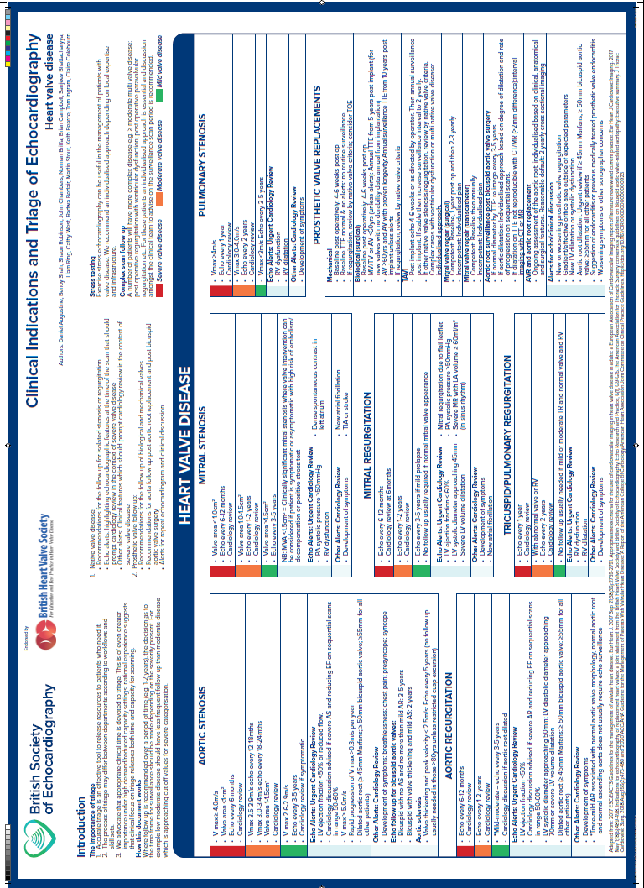
Appendix 3: Equality Analysis

Equality Analysis
Policy / Plan / proposal name:

Procedure for Echocardiographer Led Valve Clinics
Date of Policy
1st August 2016
Date due for review
1st August 2019

Lead person for policy and equality analysis

Cassandra Hammond, Lead Echocardiographer
Does the policy /proposal relate to people? If yes please complete the whole form. YES

- Identify the main aim and objectives and intended outcomes of the policy.
The purpose of this document is to provide clear guidelines to all members staff providing the echocardiographer led valve clinics and assign responsibilities and accountabililty

- Involvement of stakeholders.
This protocol has been sent out for wide consultation to all members of the clinical services unit including Cardiologists , Cardiac Physiologists and Nurses and feedback has been received

- Evidence.
Population information on www.healthprofiles.info search for Oxfordshire. This will need references

Disability: This is not relevant; all patients are treated equally to ensure their safety during a procedure using regardless of whether they have a disability.

Disability: learning disability Not relevant as all patients are treated equally during their visit to the department.
Sex
This is not relevant; all patients are treated equally to ensure their safety during their visit to the department regardless of gender.
Age:
This is not relevant; all patients are treated equally to ensure their safety during a procedure using irrigation regardless of their age
Race: This is not relevant; all patients are treated equally to ensure their safety during a procedure using irrigation regardless of their race.
Sexual orientation: This is not relevant; all patients are treated equally to ensure their safety during their visit to the department regardless of their sexual orientation
Pregnancy and maternity: This is not relevant; all patients are treated equally to ensure their safety during their visit to the department regardless of whether they are pregnant.
Religion or belief. This is not relevant; all patients are treated equally to ensure their safety during a procedure using irrigation regardless of their religion or belief
Gender re-assignment. This s not relevant; all patients are treated equally to ensure their safety during their visit to the department regardless of whether they are going through transition or have transitioned.
Marriage or civil partnerships:
This is not relevant; all patients are treated equally to ensure their safety during their visit to the department regardless of their marital or partnership status.
Carers:This protocol could involve carers being present during the procedure.

Safeguarding people who are vulnerable: The protocol encourages all patients to be treated the same way.
Other potential impacts e.g. culture, human rights, socio economic e.g. homeless people
There should be no other potential impacts as all patients are treated equally to ensure their safety during their visit to the department
Section 4 Summary of Analysis
There is no potential to discriminate.
How does the policy advance equality of opportunity? All patients are treated the same and therefore there will be no disadvantage to any group of patient

How does the policy promote good relations between groups? (Promoting understanding) The protocol encourages staff to communicate clearly with patients and between each other using universally appropriate tools and techniques such as ‘read back: confirming what has been said by repeating the message back’. Clear verbal instruction is required before, during and after the procedure. and the rest of the MDT to ensure that the patient’s procedure is performed in a safe environment. The protocol encourages staff to be aware of their roles and those of their colleagues, to ensure that the procedure is completed quickly and smoothly and that the patient has the best possible outcome. This will ensure patients receive optimal care before, during and after their procedure and that all team members are well informed

